1. **Table**

|  |  |  |  |  |  |
| --- | --- | --- | --- | --- | --- |
| **Story ID (No.)** | **Story Description** | **Expected outcomes**  **(Acceptance Criteria)** | **Actual outcomes** | **Expected Hours(h)** | **Actual taken hours(h)** |
| 01 | Login - The company staffs will be able to have access to the main menu by login with their own signed up password and username. | -A neat and clear interface  -Allowing the user to login with a previously set username/password (no sign up at this point)  -Covering passwords in asterisks  -An error message text box popping up when wrong username/password typed | - All the requirements are met but a bit differently to our expectation  - An error message text box doesn’t pop up, but instead it is instantly displayed on the current page  - The sign-up and logout functionality wasn’t expected to be done, but was essential to fulfil the tasks of the given story | 8 | 6 |
| 07 | The customers will be able to have access to the web application even without logging in, and to view car recommendations based on their conditions | -Allowing user to have a certain access to the system without logging in  -Allowing user to view some car recommendations | -The user does have the access to a page titled ‘Customer accessible page’ by clicking ‘click here if you are a customer’, but is not able to view any car recommendations. Retrieving car info isn’t an issue, but we thought we should rather first combine the data retrieved with some images of actual car designs, which is a task of sprint 2 activities | 6 | Uncompleted |
| 08 | The company staffs will be able to have access to the main menu by a simple login | -Allowing the user to move to different menus by clicking different navigation patterns provided by the page | - The requirement is successfully met, and It didn’t take too long to fulfil the task | 5 | 3 |
| 12 | The board of CRC will be able to browse particular information by typing inputs in the input field provided. | -The browser menu searches for a particular customer’s info or car’s info by typing a certain input into the input field and click Browse button  -Certain types of information are loaded up | -Every requirement is met  -However, the system shows every information it has from the database even before clicking Browse button  -A button with a + sign can load more detailed information other than the originally provided ones | 9 | 7 |
| 18 | The company staffs will be able to store particular information using blank inputs fields and some functional buttons provided. | -The page contains some input fields and the company user can save particular data using those input fields and clicking record button | -None of the requirement is met since we had problems with applying elements, such as input fields into the database | 5 | Uncompleted |
| 23 | The management staff will be able to manage (navigate, edit, delete and load) all the collected data. | -The page displays the entire information data of CRC in a tabular format | -Better than what we expected, the data dimensions are displayed in a nice manner.  -We also succeeded in providing Edit button (which doesn’t work for now though and is a task of sprint 2) | 7 | 7 |

1. **Screenshots**
   1. 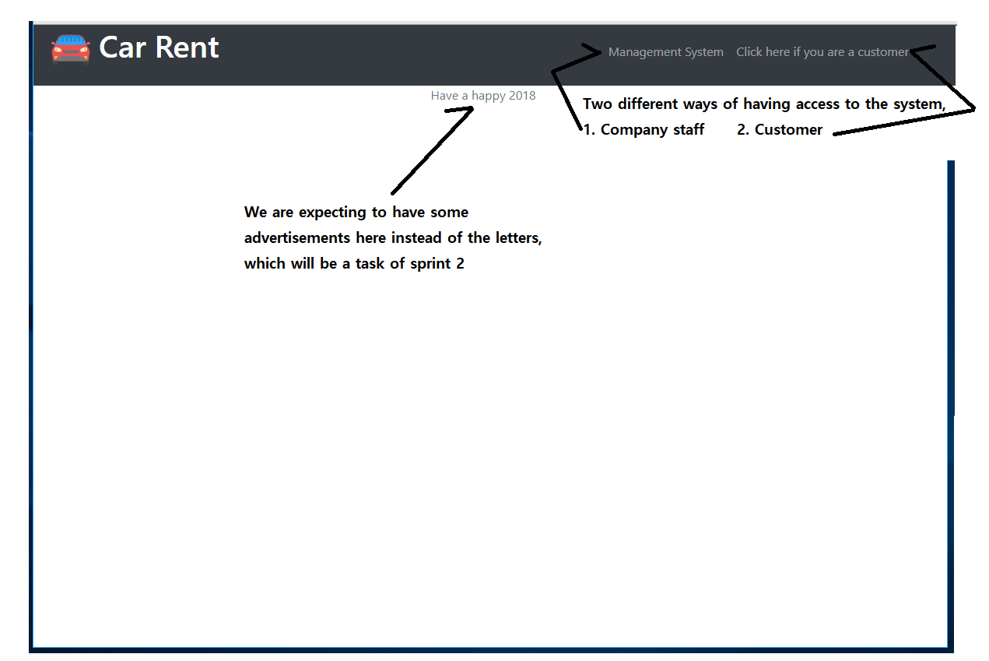**Welcome page**
   2. 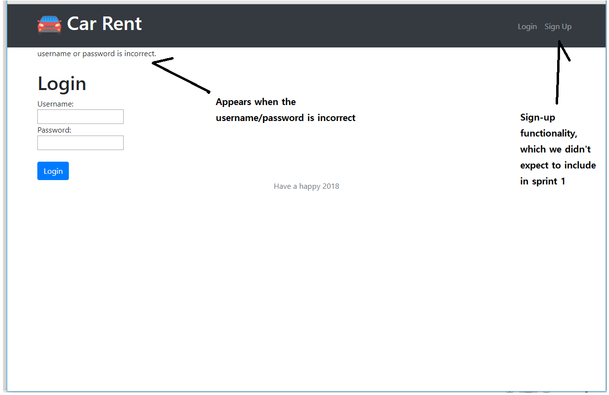**Login page**
   3. 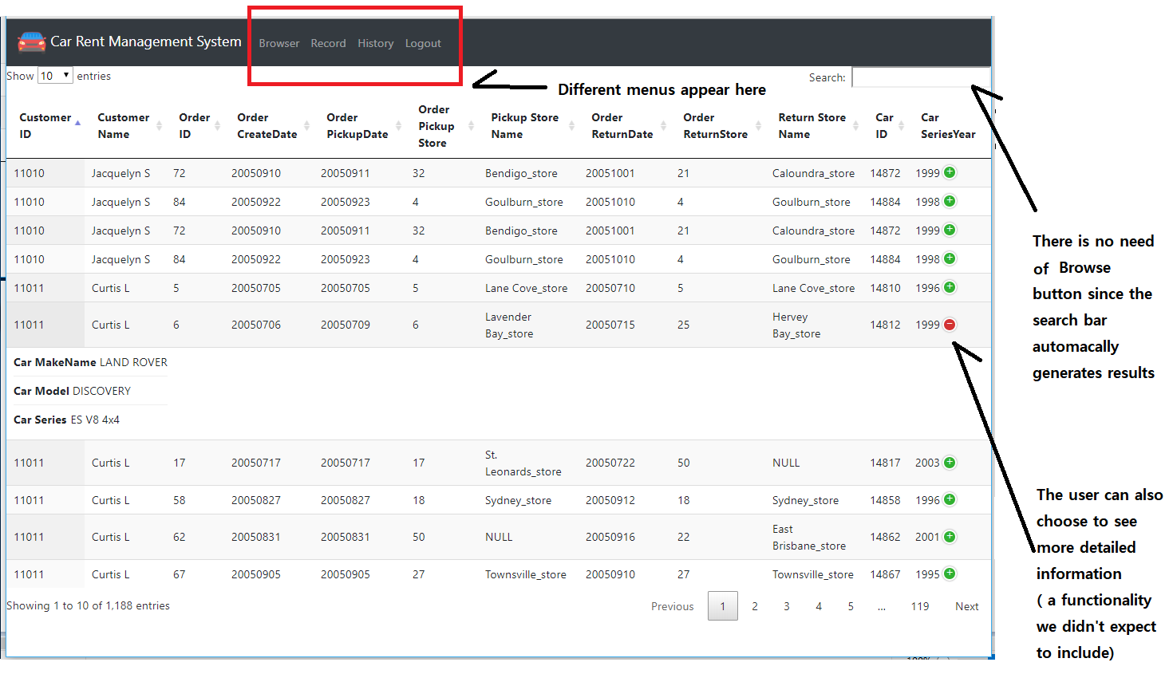**Browser menu**
   4. 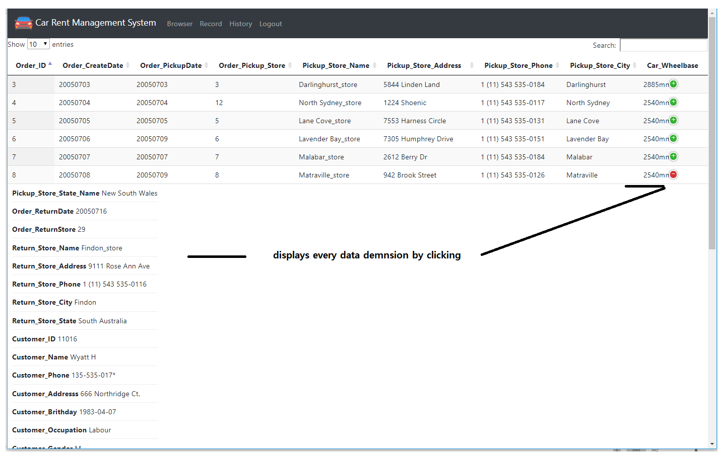**History/Data navigation**
   5. 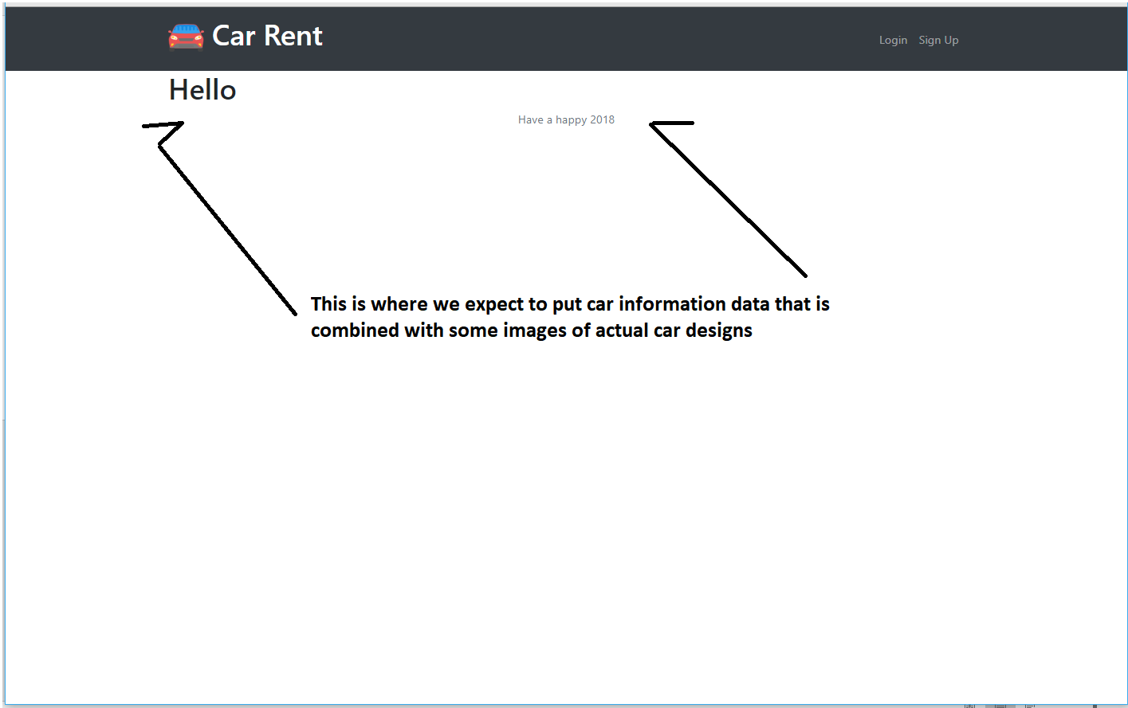**Customer accessible page**